*Developers’ Note*

* *Keith Lie*
* *Natchanon Mahaittidon*

**Project Overview**

This project is to create a Music Mixer Web-App that has simple coding logic like drag & drop feature to activate sound/music. The concept that we want to go with is a natural/ambience sound that can be listened to inside a room. There will be several key sounds that can be interacted with by users like the sound of leaves/trees, wind, bird, ocean, etc. (we are going to list it later below).

Our project might be a little different since our drag & drop mechanism is quite different from the class’s example. We will try to add the drag & drop feature inside the environment of the UI to create a more engaging and unique experience. This will be referenced below on the resources/research part.

**Key Features**

* Interactive Environment of a room (Clickable buttons that are blended inside the environment)
* Drag & drop

**Architecture**

User interface (UI) : the isometric room with 4 sides of window, those differences natural themes with simple animated illustrations (or collage art)

Drag and Drop logic: Windows are the music controller, open up to starting the sound and wider to louder

**Resources/Research**

**Reference**

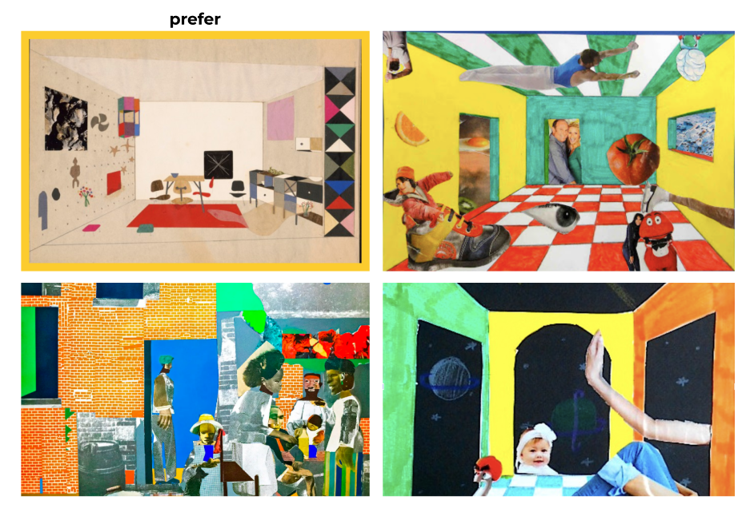

**Sound List**

**Afternoon / Morning Sound**

* Bird Chirping - <https://elements.envato.com/birds-chirping-4QDRBEJ>
* Ocean Breeze/ Waves - <https://elements.envato.com/ocean-waves-beach-house-perspective-SQB3JLZ>
* Leaves / trees / forest sound - <https://elements.envato.com/wind-tree-leaves-rustling-VAC5P8Y>

**Night Sound**

* Owl sound - <https://elements.envato.com/birds-owls-birds-owl-calls-dist-mourning-Y7XKDGC>
* Wolf Sound - <https://elements.envato.com/wolf-howling-MBLYDJU>
* Crickets - <https://elements.envato.com/crickets-night-D528TQ4>

**General Backsound**

* Calm Piano BGX - <https://elements.envato.com/calm-piano-TSTU32X>

**Licensing**

All of the sources from Envato Elements are protected and used with the terms and conditions applied that come with the Subscription of Envato Elements. These sources are hereby under the pretext of Envato Elements Commercial License or under the Royalty-Free Category (<https://elements.envato.com/license-terms>). Which can be used commercially and/or for personal use / non-commercial projects.

Therefore since this is an education-based project, it can be used.

**Sprint Timeline**

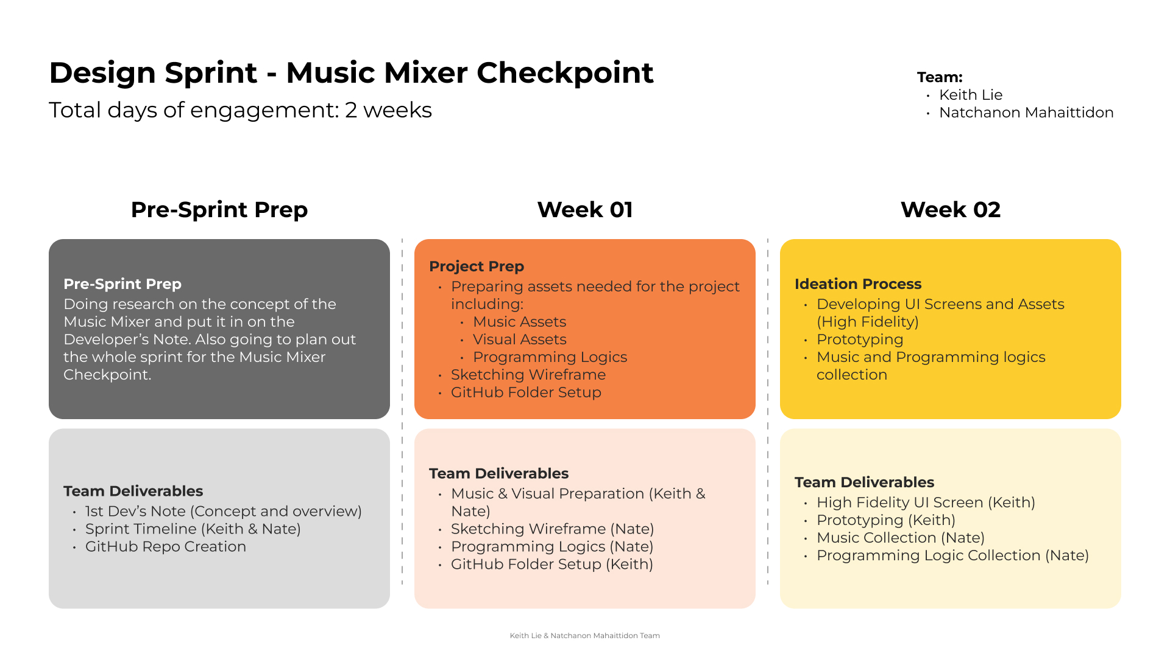

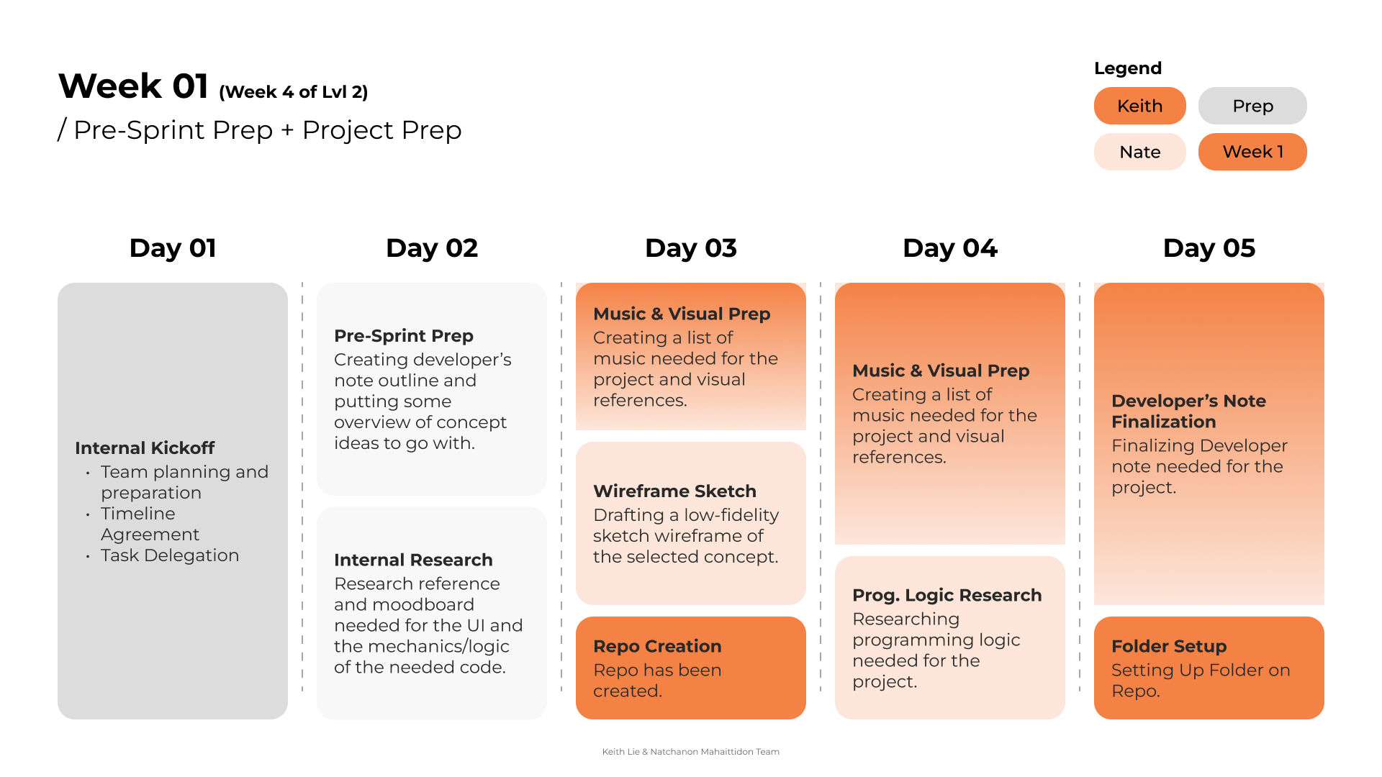

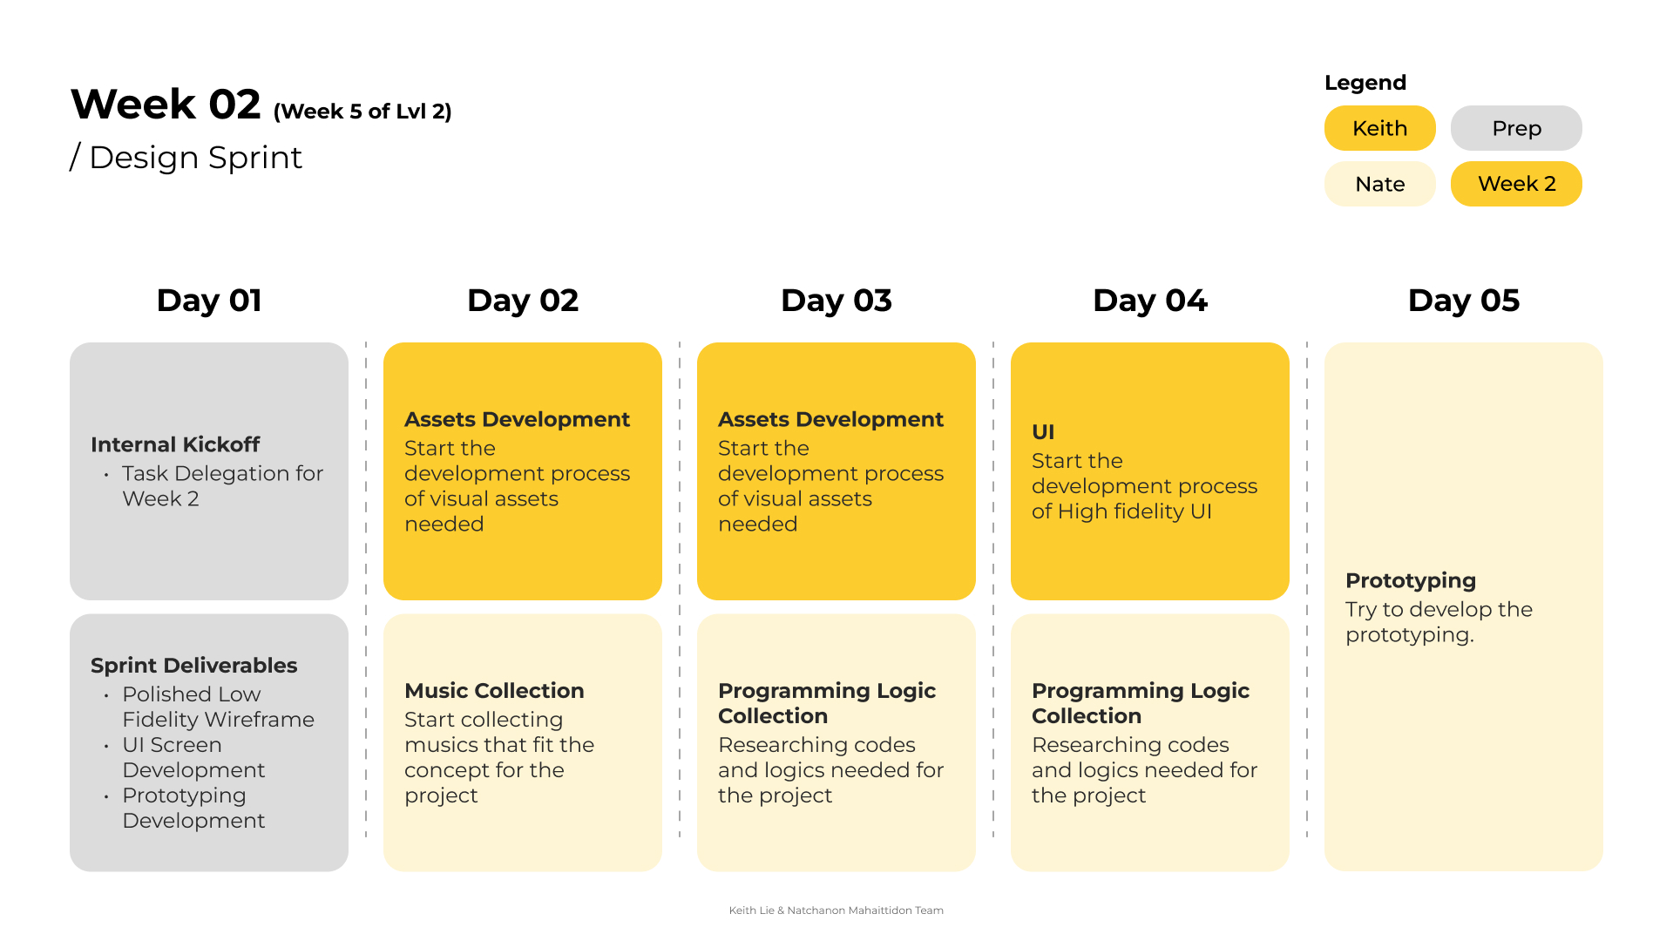

**Reference**

Images

1. <https://www.theguardian.com/books/2015/dec/07/best-architecture-books-of-the-year-2015-observer-rowan-moore>
2. <https://id.pinterest.com/pin/127930445639994608/>
3. <https://www.pinterest.jp/pin/478014947941873020/>
4. <https://jhna.org/articles/revision-and-reckoning-legacy-of-slaveries-in-northern-art/>